EXPERIMENT- 36
Recognise Watch from the Given Image using Object Recognition
Aim
To write a Python code to recognize a watch object from an image using OpenCV object recognition techniques.
Code
from google.colab import files
import cv2
import numpy as np
from google.colab.patches import cv2_imshow
uploaded = files.upload()
image_path = list(uploaded.keys())[0]
image = cv2.imread(image_path)
if image is None:
print("Error: Image not found")
else:
hsv = cv2.cvtColor(image, cv2.COLOR_BGR2HSV)
lower_bound = np.array([0,0,0])
upper_bound = np.array([180,255,30])
mask = cv2.inRange(hsv, lower_bound, upper_bound)
contours,_ = cv2.findContours(mask,cv2.RETR_EXTERNAL,cv2.CHAIN_APPROX_SIMPLE)
for contour in contours:
area = cv2.contourArea(contour)
if area > 500:
x,y,w,h = cv2.boundingRect(contour)
cv2.rectangle(image,(x,y),(x+w,y+h),(0,255,0),2)
cv2.putText(image,"Watch",(x,y-10),
cv2.FONT_HERSHEY_SIMPLEX,
0.5,(0,255,0),2)
cv2_imshow(image)
Input & Output Image
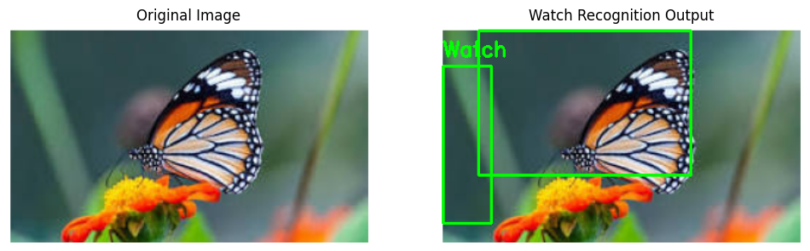Result
Thus, the watch object was successfully recognized using OpenCV.

